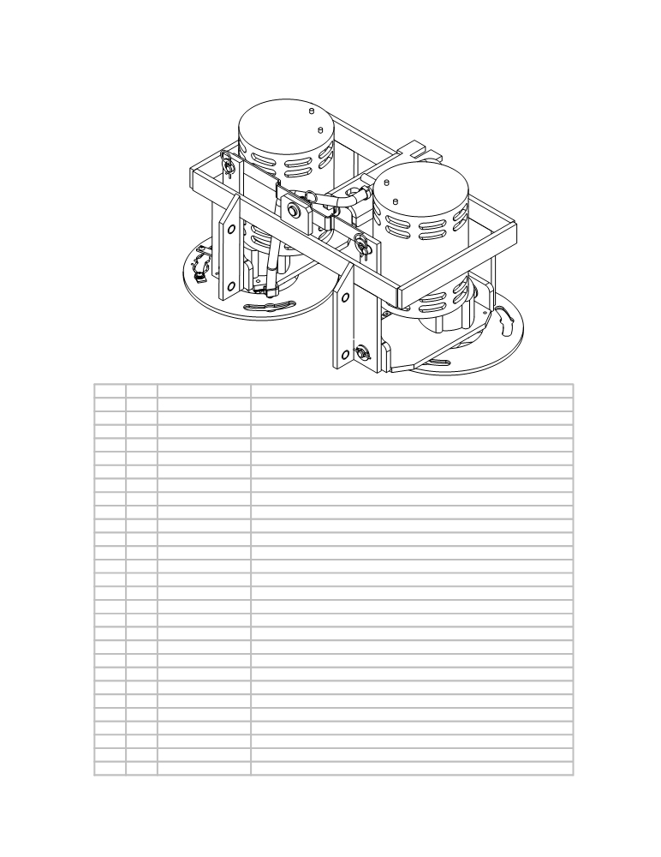

MOTOR FRAME AND MOTOR MOUNT

ITEM QTY. PART NO. DESCRIPTION
ITEM | PART NO. | DESCRIPTION | QTY.
1 | E10514 | Motor Frame | 1
2 | E12106 | MOTOR MOUNT, L.H. | 1
3 | E12107 | MOTOR MOUNT - R.H. | 1
4 | AS26/32283 | Washer | 8
5 | E81066 | Washer, 3/8" Split Lock, Zinc | 8
6 | AS26/32211 | Bolt | 8
7 | E11135 | 3/4 SAE FLAT WASHER | 4
8 | E11723 | 1/4x1/4x1-KEYSTOCK | 2
9 | >> see >> | (see Drive Hub Assembly parts list) | 1
10 | >> see >> | (see Drive Hub Assembly parts list) | 1
11 | E10135 | 3/8 USS FLAT WASHER | 16
12 | E11500 | 7/16-20 x 1 1/4 UNF Gr5 HHCS Zinc Pkg | 2
13 | AS26/32337 | Bolt | 2
15 | E10507 | BRUSH MOTOR (P56SG600)(36v) | 2
16 | AS261105 | Cable Mount - right side (brush drive only) | 1
17 | AS261106 | Cable Mount - left side (brush drive only) | 1
18 | AS261100 | Actuator Bar (brush drive only) | 1
19 | E11719 | Hairpin Cotter | 2
20 | AS26600 | Cable for motor control (brush drive only) | 2
21 | AS26245 | Nyloc nut (brush drive only) | 2
22 | E11136 | 3/8 SAE FLAT WASHER | 3
23 | AS26255 | Retaining ring (brush drive only) | 2
24 | E12407 | 1/2 SAE FLAT WASHER GR8 PKG | 6
25 | E11146 | 3/8-16 UNC ELASTIC LOCKNUT | 1
26 | AS261119 | Linkage Arm (brush drive only) | 2
28 | E11719 | Hairpin Cotter | 6
29 | E10518 | MOTOR LINKAGE | 2
30 | E11179 | 1/2X1.25 CLEVIS PIN | 4

1 1 AS261122 Motor Frame
2 1 AS26/321123 Motor Mount - left side
3 1 AS26/321124 Motor Mount - right side
4 8 AS26/32283 Washer
5 8 AS26/32292 Lock Washer
6 8 AS26/32211 Bolt
7 4 AS26/32281 Washer
8 2 AS26/32338 key for brush motor
9 1 >> see >> Drive hub left assembly (see Drive Hub Assembly parts list)
10 1 >> see >> Drive hub right assembly (see Drive Hub Assembly parts list)
11 16 AS26/32285 Washer
12 2 AS26/32286 Washer
13 2 AS26/32337 Bolt
15 2 AS26050 Brush motor - 24 volt
16 1 AS261105 Cable Mount - right side (brush drive only)
17 1 AS261106 Cable Mount - left side (brush drive only)
18 1 AS261100 Actuator Bar (brush drive only)
19 2 AS26831 Swivel Pin (brush drive only)
20 2 AS26600 Cable for motor control (brush drive only)
21 2 AS26245 Nyloc nut (brush drive only)
22 3 AS26/32282 Washer
23 2 AS26255 Retaining ring (brush drive only)
24 6 AS26/32278 Washer
25 1 AS26/32244 Nyloc nut
26 2 AS261119 Linkage Arm (brush drive only)
28 6 AS26/32334 Hair pin cotter
29 2 AS261146 Motor Linkage (Traction Drive Only)
30 4 AS26/32248 Clevis pin

- 33 -

